1. Getting started

* What is JIRA
* Uses of JIRA
* Features in JIRA
* [How to get access to JIRA](https://confluence.oraclecorp.com/confluence/display/ALM/On-Boarding+for+ALM+Jira+-+Confluence)

2. Day in a life of

* Hubster
* Browse a project
* [Manage sprints/tasks](https://confluence.atlassian.com/jirasoftwarecloud/monitoring-the-progress-of-a-sprint-764478122.html)
* Create and manage Issue Type
* Create and manage Issue Type Scheme
* View the workflow
* View voters and watchers
* Create Log work on an issue
* Hub Managers
* Manage Roles for the project
* Create and update project
* Manage Project versions
* Delete Issue Type
* Delete Issue Type Scheme
* Manage Log work on an issue
* Edit work logs
* [Task management](https://confluence.atlassian.com/jiracoreserver079/task-management-950289299.html)
* [Start and end sprint](https://confluence.atlassian.com/jirasoftwarecloud/planning-sprints-764478112.html)
* Create and Manage Dashboards
* Create and Delete Sprints
* Generate Reports
* Hub Leaders
* Boards
* [Reporting](https://confluence.atlassian.com/adminjiraserver071/reporting-935895403.html)

3. Internal Projects

* How to manage scrum project
* Reporting
* [Dashboard](https://confluence.atlassian.com/jiracorecloud/configuring-dashboards-765593585.html)

4. APPENDIX

* FAQ
* [What is a project?](https://confluence.atlassian.com/jiracorecloud/create-a-project-in-your-new-jira-experience-937885967.html)
* How to create a project?
* What is an issue?
* [What is a workflow?](https://confluence.oraclecorp.com/confluence/display/ALM/Create%2C+Modify+Workflows%2C+Workflow+Schemes+in+JIRA)
* [What is a sprint?](https://confluence.atlassian.com/jirasoftwarecloud/sprints-946603733.html)
* [How to raise a My Help request for JIRA?](https://confluence.oraclecorp.com/confluence/pages/viewpage.action?pageId=178653966)
* [Adding and customizing gadgets to dashboard](https://confluence.atlassian.com/jiracorecloud/adding-and-customizing-gadgets-765593580.html)
* [Set and manage project permissions](https://youtu.be/wvdVNpgG34M)
* RESOURCES

1. Learning Jira Software ([1 hr course in Lynda)](https://www.lynda.com/course-tutorials/Learning-JIRA-Software/545920-2.html?org=oracle.com)

2. Jira Software Basic Administration ([1 hrs course in Lynda](https://www.lynda.com/JIRA-tutorials/JIRA-Software-Basic-Administration/585265-2.html?org=oracle.com))

# What is JIRA?

JIRA is an Incident Management Tool used for Project Management, Bug Tracking, Issue Tracking and Workflow. JIRA is based on the following three concepts – Project, Issue and Workflow

* JIRA is an incident management tool.
* Atlassian Inc., an Australian Company, develops JIRA.
* JIRA is a platform independent tool; can be used with any OS.
* JIRA is multi-lingual tool – English, French, German, Japanese, Spanish, etc.
* JIRA supports MySQL, Oracle, PostgreSQL and SQL server in the backend.
* JIRA can be integrated with many other tools – Subversion, GIT, Clearcase, Team Foundation Software, Mercury, Concurrent Version System and many more

# Uses of JIRA

Following are some of the most significant uses of JIRA.

* JIRA is used in Bugs, Issues and Change Request Tracking.
* JIRA can be used in Helpdesk, Support and Customer Services to create tickets and track the resolution and status of the created tickets.
* JIRA is useful in Project Management, Task Tracking and Requirement Management.
* JIRA is very useful in Workflow and Process management.

# Features in JIRA

Following are some of the features in JIRA.

* Agile Reporting (like Scrum, Kanban)
* Dashboard
* Task Details
* Notifications
* Power search

How to get access to JIRA

* 1. Login to [OIM](https://oim.oraclecorp.com/identity/faces/home).
  2. NOTE: Add the JIRA ODCS Users entitlement to the cart first and checkout.
  3. Once JIRA ODCS Users is approved you need to go back and request the other entitlements
  4. Add the desired entitlements to the cart and checkout. Make sure you pick the right entitlements (both production and stage)
     + Jira ODCS Users:  Required by everyone. Users with this entitlement can log in and in projects with default-configured roles, create, update and comment on issues.
     + Jira ODCS Developers: Required by Developers, QA folks and Administrators. In projects with default configured roles, users with this entitlement can do things such as assign or be assigned issues, log work against issues, and close issues.
     + Jira ODCS Administrators:  Users with this entitlement can create groups (including org_ww and directs_ww groups that are synced from corresponding stbeehive groups). In projects with default configured roles, such users are projects administrators and can manage project attributes such as versions, components and roles. This role is for senior members and higher.

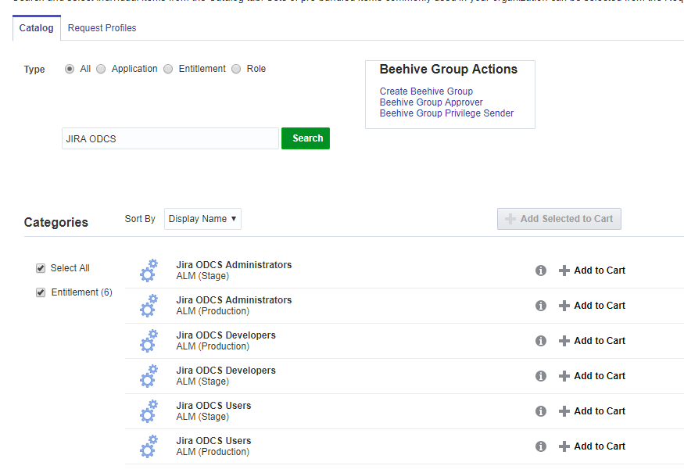

Click on **Add to cart,** enter **Justification** details and click on **Submit**

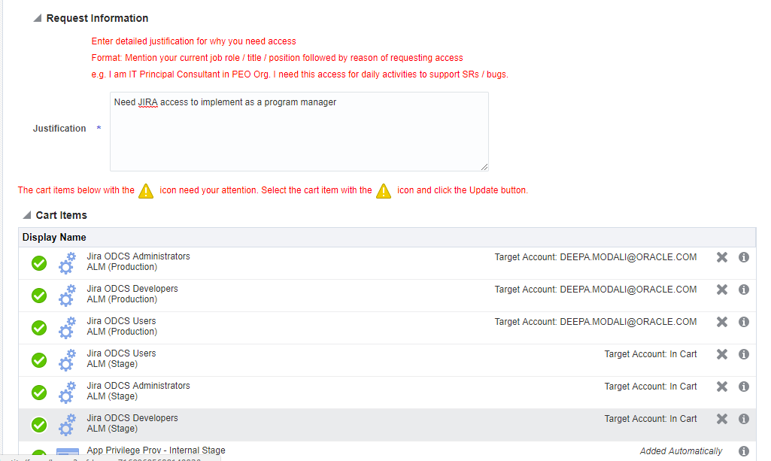

* Once your account is approved, log in to JIRA
  1. [JIRA UAT](http://jira-uat.us.oracle.com/)
  2. [JIRA Prod](http://jira.oraclecorp.com/)
  3. Subscribe to ‘**alm_users_ww_grp**’ for Central JIRA outages.

# How to Create a New Project

You can create your own project in UAT. However, for Production you will need to raise an SR

[Raise an SR](https://confluence.oraclecorp.com/confluence/display/ALM/On-Boarding+for+ALM+Jira+-+Confluence)

Attach 

Once the SR is raised, e-mail sadia.faber@oracle.com (US Timezone) for approval. Mention that your team has been on-boarded from the OAL PMO Office.

Attach the email approval to the SR.

Once the SR is approved, the CJT (Central Jira Team) will create your project in Prod.

To create a project, the user should login as a JIRA Service Desk Admin and then Click on

1. Project 🡪 Create Project
2. Select type of the Project & click on next

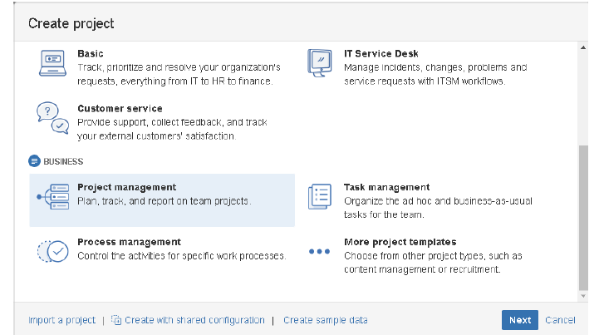

1. Provide details and Submit

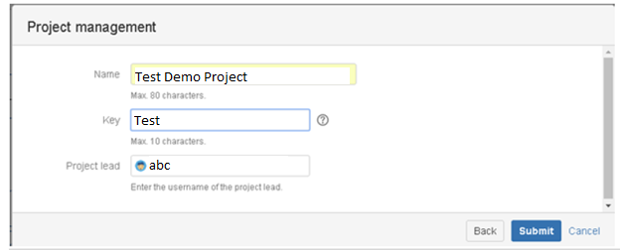

1. Empty Dashboard is shown, Add team members by clicking on the Invite your team button

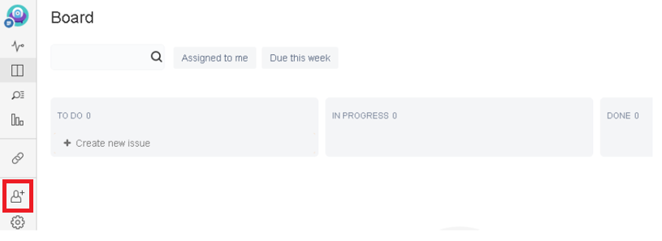

# Browse a Project

As a user, we can browse the projects that we are working on.

1. Click on Projects 🡪 Find your project

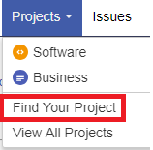

1. Search for the project

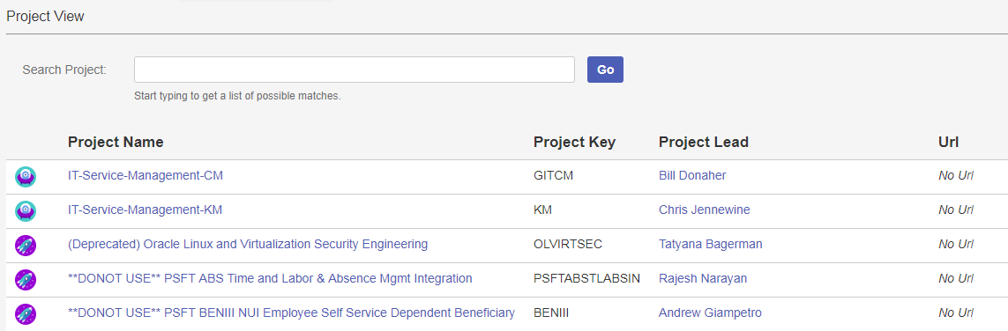

# Creating an Issue Type

1. Click Administration Settings icon and Select Issues option from the list.

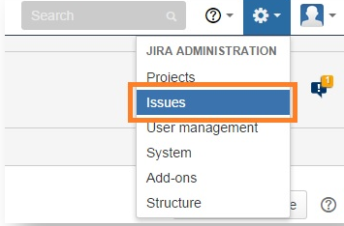

1. In the next screen, Click Issue type in the left side panel.

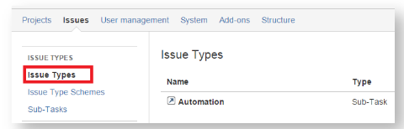

1. In the next Screen it will show the all the Issue types. Click to create a new Issue Type

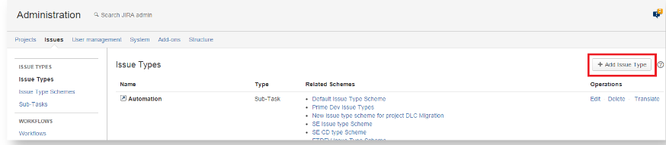

1. Provide the Name, Description (optional) & Type. Click on "Add"

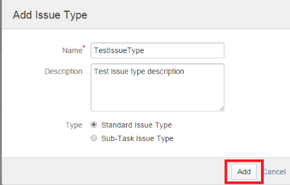

1. Once Add, it will display in Issue type list

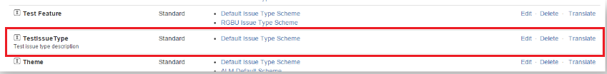

# Editing an Issue Type

1. Click Administration Settings icon and Select Issues option from the list.



1. In the next screen, Click Issue type in the left side panel.



1. To edit the issue type click on "Edit"

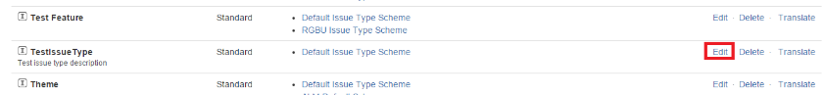

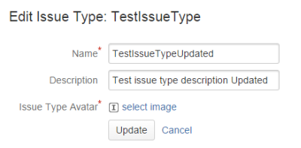

# Creating an Issue Type Scheme

Issue type scheme controls, which issue types, will be available to a set of JIRA projects.

1. Click Administration Settings icon and Select Issues option from the list.



1. In the next screen, Click Issue type scheme in the left side panel.

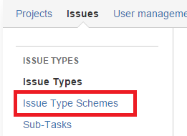

1. In the next Screen, it will show the all the Issue type schemes.

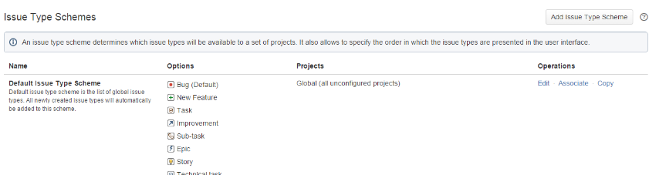

1. There are two types of Issue type scheme in JIRA. They are,

* Default Issue type scheme – All newly create Issue types will be listed under this scheme.
* Scrum Issue type scheme – Agile scrum projects will use this scheme.

1. Click to create a new Issue type scheme

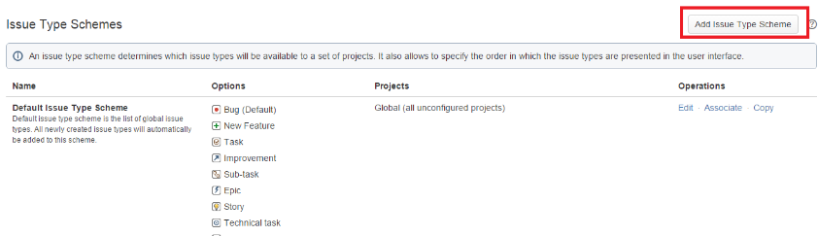

1. It will Opens below form, provide following details in that form
   1. Enter Scheme Name
   2. Enter Description
   3. Select Default Issue type for the scheme
   4. Drag & drop Issue types for scheme from available Issue types and Vice versa

Issue types order can also be re-arranged (moving up or down) according to our project needs.

To add new Issue type to this scheme, Click Add Issue type on the top right. Once all the information are entered, click on SAVE

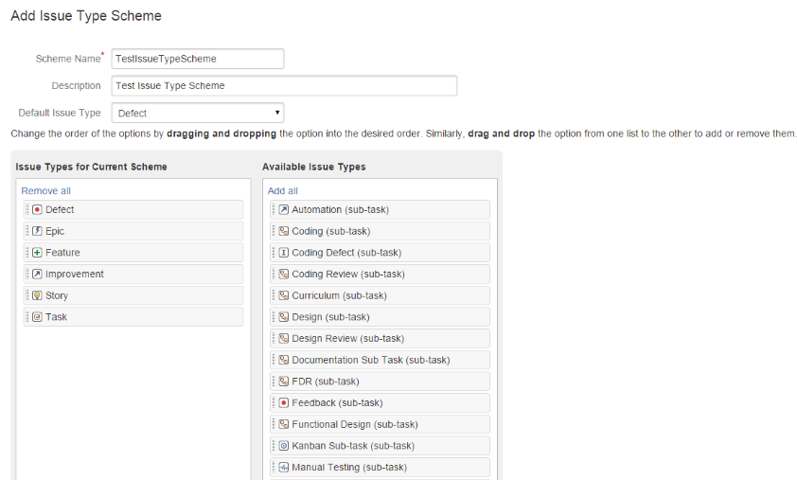

1. Once save, it will display in Issue type schemes list

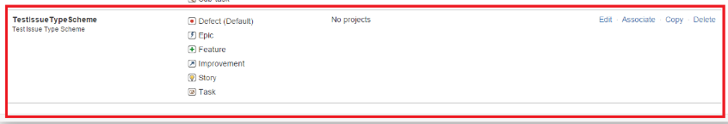

1. To associate projects with this newly created scheme, Click Associate & then Select the project (multi-select allowed), Click Associate and follow migrations until finish to complete the association

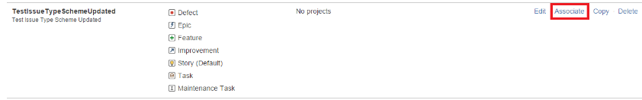

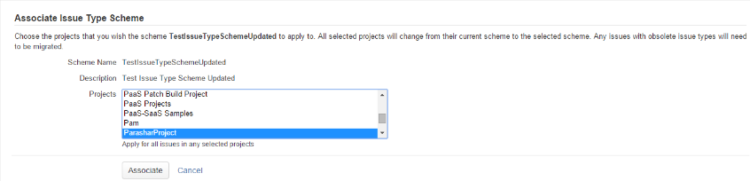

# Creating a Screen

To configure the fields visible on screen.

1. Click Administration Settings icon and Select Issues option from the list.



1. In the next screen, Click Screens in the left side panel.

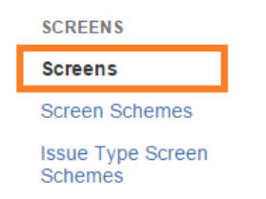

1. In the next Screen, click on Add Screen, enter Name and Description click on Add.

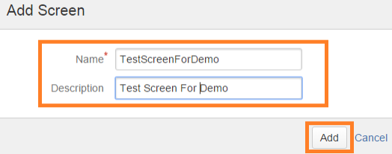

1. On click of "Add" button, the screen is navigated to "Configure Screen" where you can add fields for your currently created screen by typing the field names and choosing from the list box.

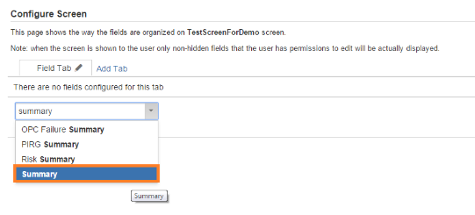

1. You will see the field being added to the screen.

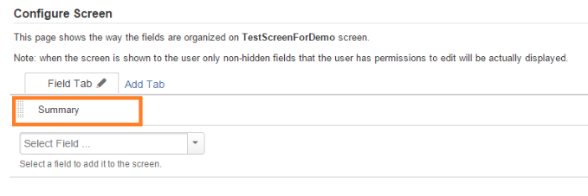

1. Group fields in a new tab by clicking on "Add Tab", and add the required fields

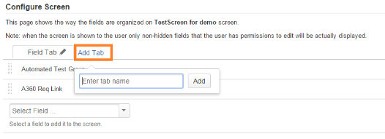

# View the Workflow

1. Click Administration Settings icon and Select Issues option from the list.



1. Click on Workflows

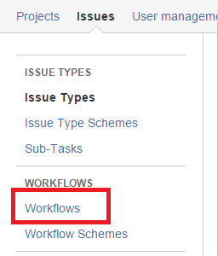

1. Following screenshot displays all the workflows listed.

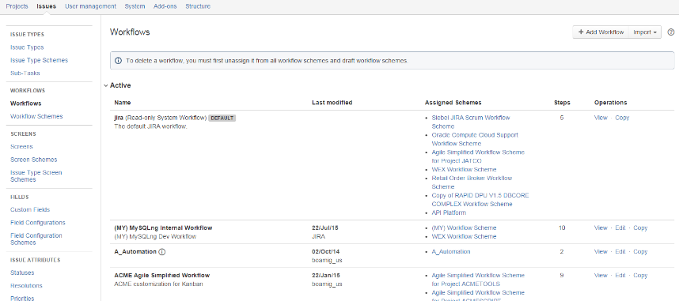

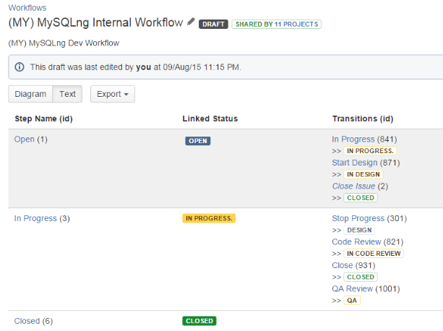

1. Only active workflows are displayed by default, to see inactive workflows navigate to bottom of the page and expand the inactive section

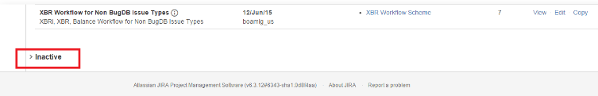

# Sharing and Exporting an Issue

1. Click Administration Settings icon and Select Issues option from the list.



1. Click on the Issue you want to Share/Export
2. It will Opens a Pop-up window, Click on view details it will show the Issue details.

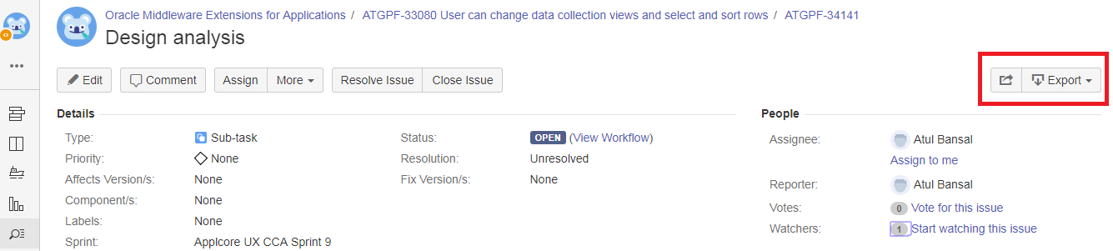

1. Click on Share button on the top to Share the Issue with others, Provide details & Share.
2. To export Click on Export button, choose the Export format, file name, location, and Save the file

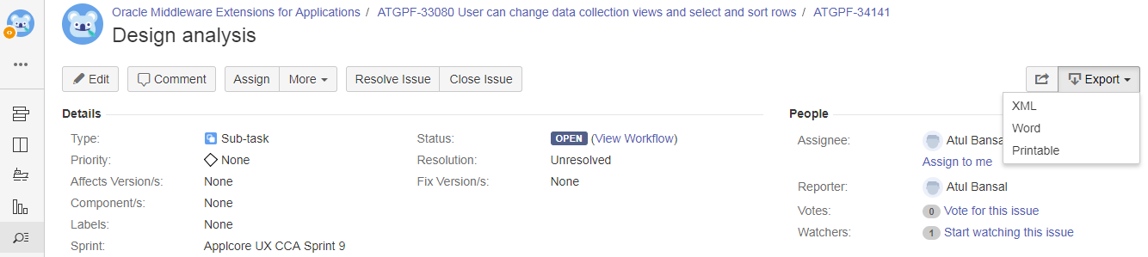

# View voters and watchers

1. Click Administration Settings icon and Select Issues option from the list.



1. Click on the Issue you can see
   1. The View Voters custom field – this field allows you to view all of the users who have voted for an issue, as well as search for all issues voted for by a particular user.
   2. The View Watchers custom field – this field allows you to view all of the users who have watched an issue, as well as search for all issues watched by a particular user.

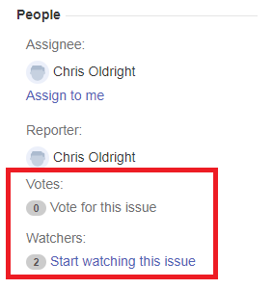

# Manage Project Versions

Versions are points-in-time for a project. They help you schedule and organize your releases. Once a version is created and issues are assigned to it, you can use the version to filter information in various reports.

1. Select the Project, Click on settings

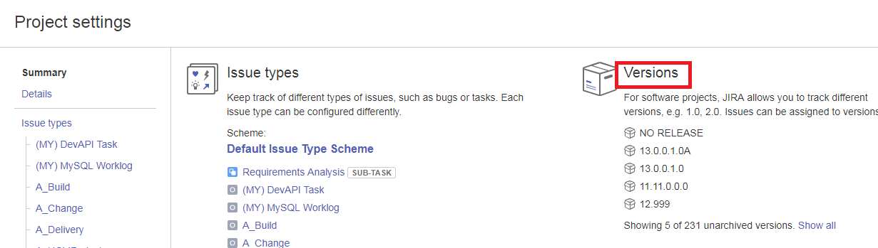

1. The Versions or Releases page is displayed, showing a list of versions and each version's status. From here you can manage the project's versions
2. Each version can have any of the 3 status
   1. Released — a bundled package
   2. Unreleased — an open package
   3. Archived — a historical snapshot of a package

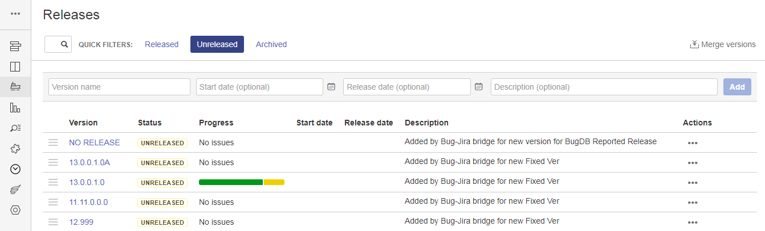

1. You can merge one version into another and move its issues to the desired version, Click on the Merge Versions.

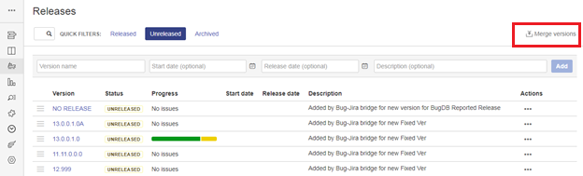

In the drop down select the Version From and Version To and Click on Merge

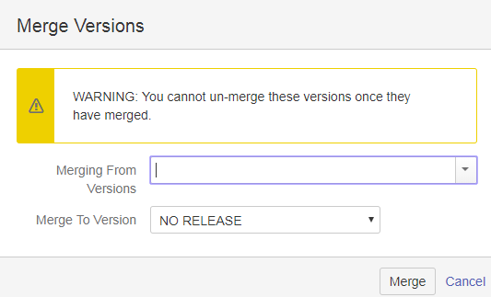

1. You can edit and delete the version details by selecting the actions menu (…).

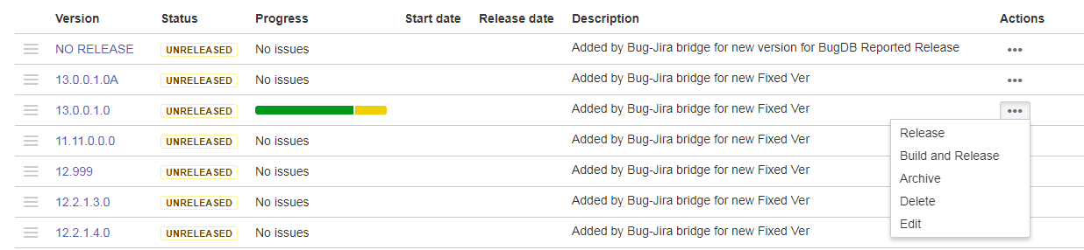

1. Update the necessary fields and Click on save

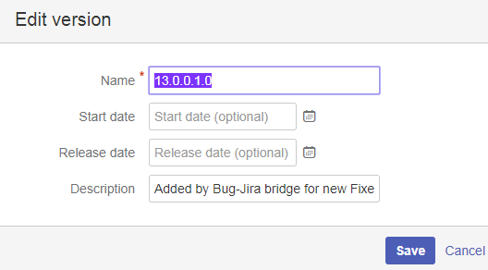

1. Find the version you want to delete and click on Yes

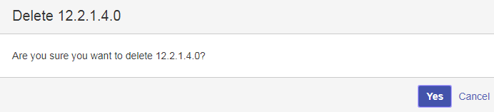

# Create Log Work on an issue

1. Click Administration Settings icon and Select Issues option from the list.
2. Click on the Issue, More 🡪 Work Log. Fill in the following Log Work fields, and click on Log button

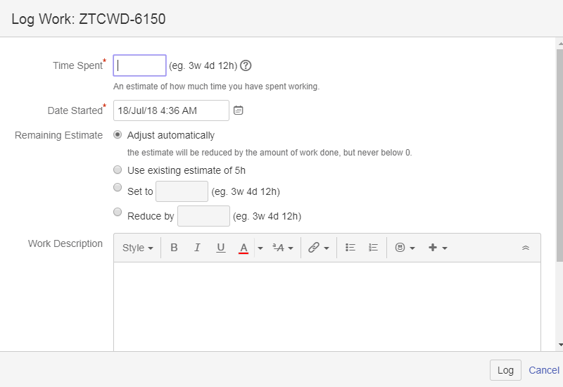

# Manage Log work on an issue

1. Click Administration Settings icon and Select Issues option from the list.
2. Open the Work Log tab, Select the entry you want to edit and click on Update.
3. Open the Work Log tab, Select the entry you want to delete, and click the trashcan icon.

# Generate Reports

We can generate reports in JIRA very easily. Reports are used to track the progress of the issues effectively

1. Select the project, Click Reports option on the Left-side bar.



1. Select the report that you want to generate the report for.

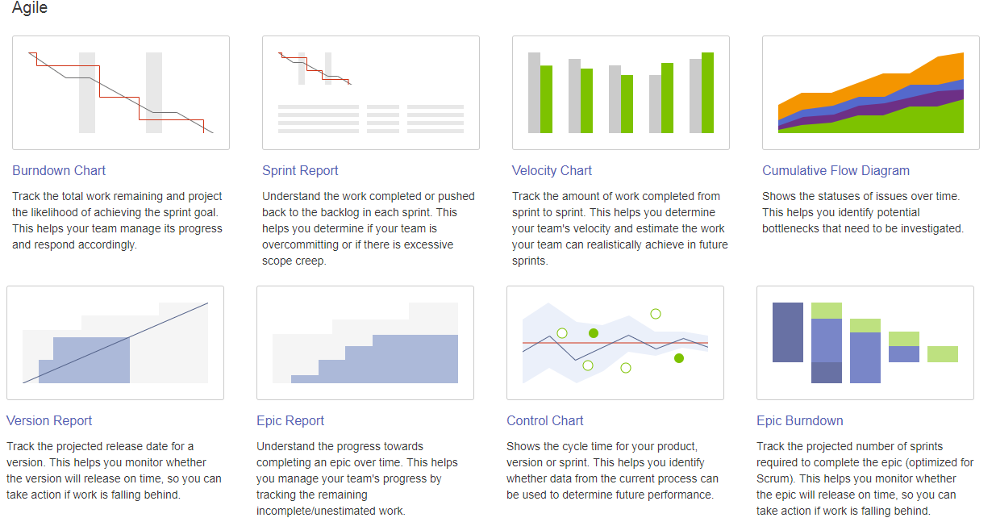

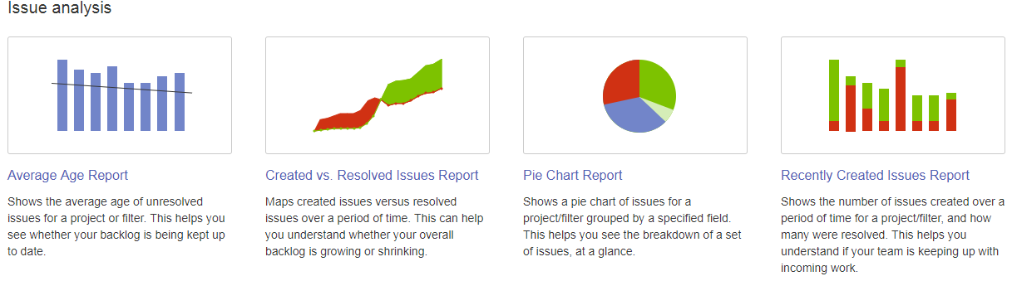

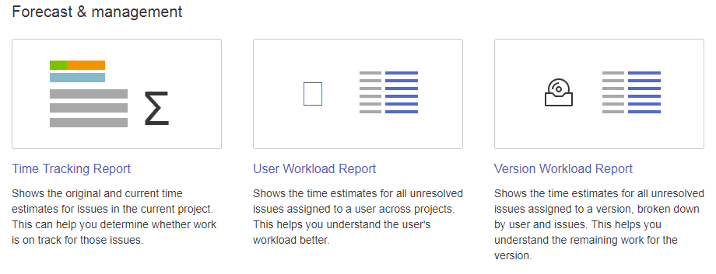

1. Provide the required details and click on next, the report is generated.

# What is a Project?

A Jira Software project is a collection of issues and tools that allows your team to coordinate the development of a piece of software. Every project contains configurable boards and workflows that you can create and customize to fit your team’s needs.

# What is an Issue?

**Issues** represent work to be performed. From a functional perspective, an issue is the base unit for JIRA. Users create issues and assign them to other people to be worked on. Project leaders can generate reports on issues to see how everything is tracking.

* An issue can belong to only one project
* There can be many different types of issues
* An issue contains many fields that hold values for the issue

# What is an Issue Type?

An 'issue type' is basically a type/category of any issue. An issue can be categorized as Bug or Task or Story, etc., JIRA has ability to configure custom issue types along with the default issue types available.

JIRA allows two types of issue types

* Standard Issue type - An issue type that is independent/parent issue type
* Sub-Task issue type - An issue type that is child of another issue which is of the standard issue type

# What is an Issue Type Scheme?

An 'issue type scheme' defines a subset of issue types, which helps in:

* Restricting the set of available issue types for a project
* Controls the order of available issue types
* Specifying the default issue type shown to your users for a project.

A single-issue type scheme can be “re-used” across multiple projects, so that a group of similar projects (i.e. projects that might be used for similar purposes) can share the same issue types.

# What is a Field?

Fields are the most basic unit of data in JIRA. They hold data for issues and give meaning to them. Fields in JIRA can be broadly categorized into two distinctive categories, namely, system fields and custom fields. They come in many different forms, such as text fields, drop-down lists, and user pickers. Fields and the topics

* Fields hold values for issues
* Fields can have behaviors (hidden or mandatory)
* Fields can have a view and structure (text field or drop-down list)

# What is a Workflow?

Workflow is a record of statuses and transitions of an issue during its lifecycle. A status represents the stage of an issue at a particular point. An issue can be in only one status at a given point of time like Opened, To-Do, Done, Closed, Assigned, etc.

# What are Statuses and Transitions?

Status - A status represents the state of an issue at a particular point in a specific workflow. An issue can be in only one status at any given point in time.

Transition - A transition is a link between two statuses that enables an issue to move from one status to another. For an issue to move from one status to another, a transition must exist.

# What is a Workflow Scheme?

A workflow scheme helps define a set of mappings between a workflow and an issue type. Workflow scheme can be associated with a JIRA project which can have mappings defined for workflows to issue types.